Designing a good Investigation to trial a new anti-ageing cream.

You have to decide:

•Will you test it on people straight away?
•What testing methods are normally used on new medicines?
•What age group will you test it on? Why?
•Gender? Why?
•Number of people. Explain your decision
•Do you need a control group? If so what will you use on them? Explain your decision
•How long will you test it for?
•What will you measure?
•How will you know if it is effective?
•How should you choose the people?
•Are there any confounding variables that can be controlled?
•Who should conduct the experimental trial?
•Should the people in the trial know if they are getting the test cream or a placebo?
•Should the assessors know who had the test cream?
•How could the results be made more reliable?
•Could your study be made more accurate?
•How could you get the public to believe your results?
•Would it be sensible to choose to test two different creams on different sides of one person’s face?
•Give reasons for and against.

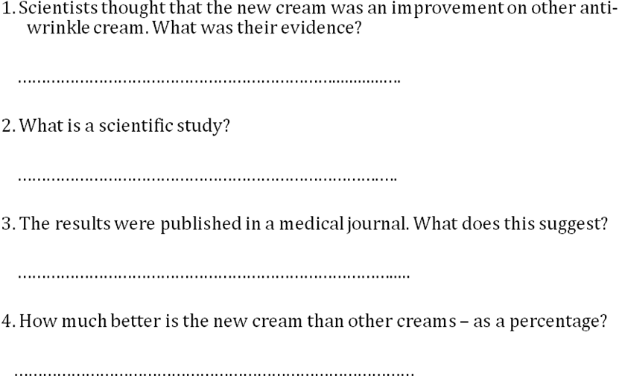

5. The ingredients in the cream increased the production of fibrillin in the skin. Suggest what type of protein fibrillin is?

…………………………………………………………............….

6. Why did the cream not just contain fibrillin?

………………………………………………………………….….

7. The lupin extract increases the production of the protein fibrillin. Suggest how this might happen.

…………………………………………………………………….....

8. What unexpected side effects might occur?

…………………………………………………………………………
9. Why is it important that the research was unbiased?

……………………………………………………………………..

10. Was the research conducted in an unbiased manner?

…………………………………………………………............….

11. How could the professor show that his research was unbiased?

………………………………………………………………….….

12. Can you conclude that the cream is effective?

…………………………………………………………………….....

13. What role did the media play in the promotion of this cream?

…………………………………………………………………………

14. What evidence is there that these claims are not just false claims?

……………………………………………………………………..

15. Would the cream only remove 70% of Wendy’s wrinkles?

…………………………………………………………............….

16. Would Sue get even better results by using twice as much?

………………………………………………………………….….

17. The new cream is twice as good as normal anti-wrinkle creams but the new cream was found to be effective in 70% of the people who tested it. What does this tell you about the effectiveness of normal anti-wrinkle creams?

……………………………………………………………………..

18. Is the method of measuring the effectiveness of the new cream accurate?

…………………………………………………………............….

